Final Report - Battle of Neighborhoods

Introduction & Business Problem

Select the best neighborhood to open Indian restaurant etc. in central Toronto.

Understanding the similarities and differences between the neighborhoods using unsupervised K-Mean Clustering Algorithm and other machine learning technique.

Data

Opening new Cafe chain in Chicago To find out various probable areas in and around Chicago, we need to find out various neighborhood in Chicago and their geographical locations. we can get list of neighborhood from wiki page https://en.Wikipedia.org./wiki/List_of_postal_codes_of_Canada:_M

We need to scrap the web page and load into dataframe and find out geographical locations for all neighborhoods in Chicago. Once data for all neighborhood prepared then find all venues related to cafe present in Chicago from Foursquare app and cluster data to find feasible areas to open cafe chain in Chicago area.

Methodology

As per business problem we need to find out best possible location to open Indian restaurant in central Toronto based on Indian population.

Analytically we need to divide neighborhood of central Toronto into different cluster and find best neighborhood to open Indian restaurant based on Indian population.

Results

Central Toronto neighborhood

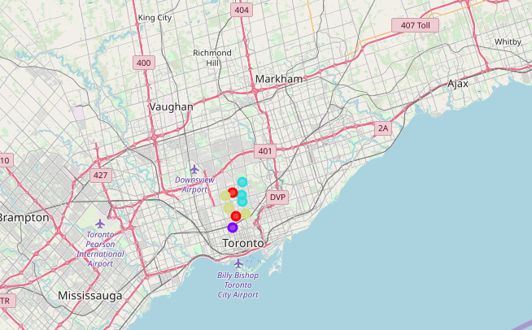

Indian restaurant in central Toronto

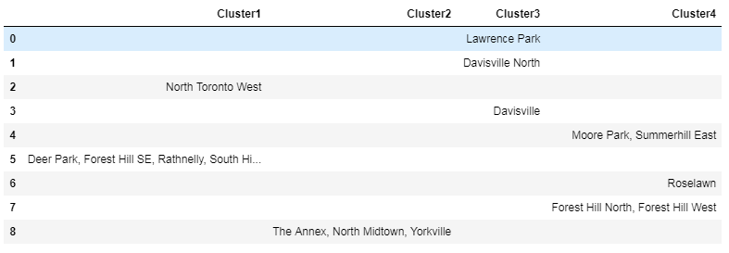

Conclusion

From the analysis we can concludes that,

as per population distribution and cluster analysis we can suggest opening new Indian restaurant in neighborhood area in and around North Midtown or Yorkville areas.

Hence North Midtown or Yorkville is best options!